|  |  |  |  |
| --- | --- | --- | --- |
| Course: | HD in Artificial Intelligence and Robotics |  | Official Use |
| Course code: | EG114728 |  |
| Module: | Industrial Automation |  |
| Module code: | MBS4521 |  |

**Lab 3:**

**Electro-pneumatic Circuits II**

|  |  |  |  |
| --- | --- | --- | --- |
| Student Name: | Cheung Tsz Chun Noddy |  | **Notes to Students**:   1. Maximum of 4 members per group for software/hardware development 2. Submit this lab sheet in pen writing 3. **Individual submission required** 4. Use spaces given for each part 5. Glue print out in specified spaces 6. Due date will be given in lab session 7. A maximum of 5% will be deducted for untidiness 8. Late submission will normally not be accepted |
| Student number: | 220171174 |  |
| Names of other members: | 1.Lai Ho  2.Lai Ka Ming  3.Lui Shing Tak |  |
| Date received:  Due date: | 1/4 , 30/4 |  |
| Signature: | Cheung Tsz Chun Noddy |  |

**Objective**

After completion of this lab, students should be able to:

1. build circuits with more than two cascade groups by using double solenoid or single solenoid control valves

2. design electrical ladder diagrams with emergency buttons.

**Procedures**

**For a specific assembly line, the following control sequence is given:**

**A+, B+, A-, C+, C-, B-**

**A1. Design a complete circuit using double acting cylinders and 5/2 double solenoid valves for a single cycle operation. (20%)**

1. **Cascade groups**
2. **Block diagram**
3. **Displacement-time diagram**
4. **Pneumatic sub-circuit**
5. **Electrical ladder**

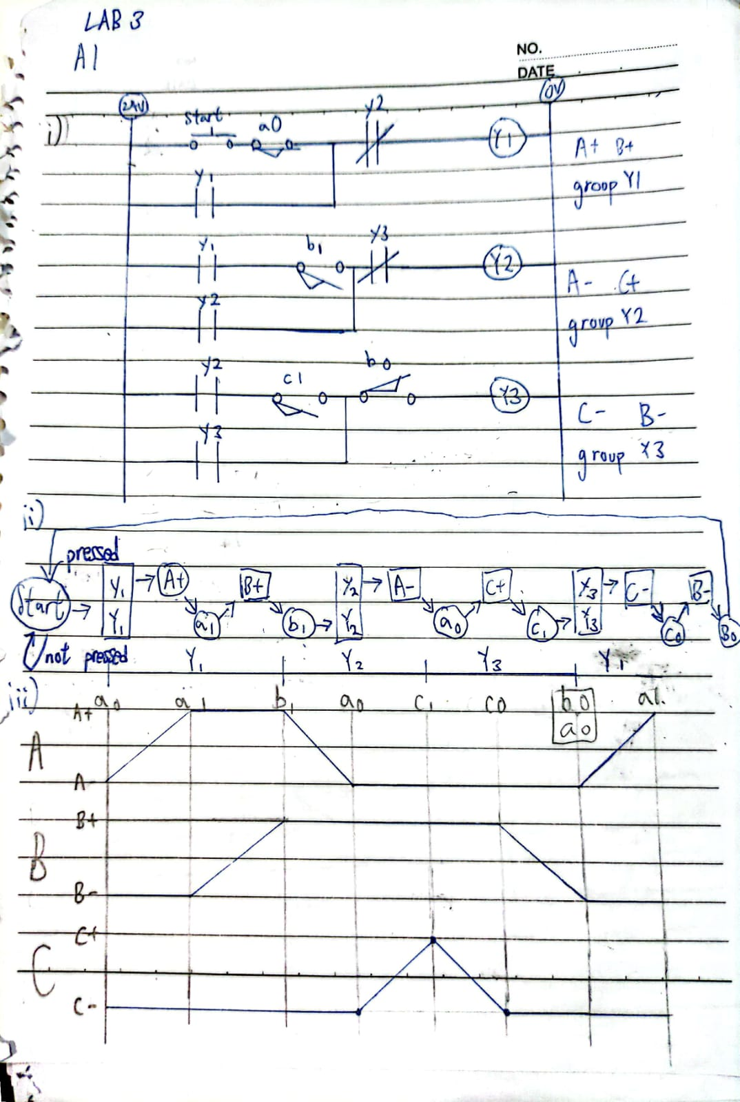

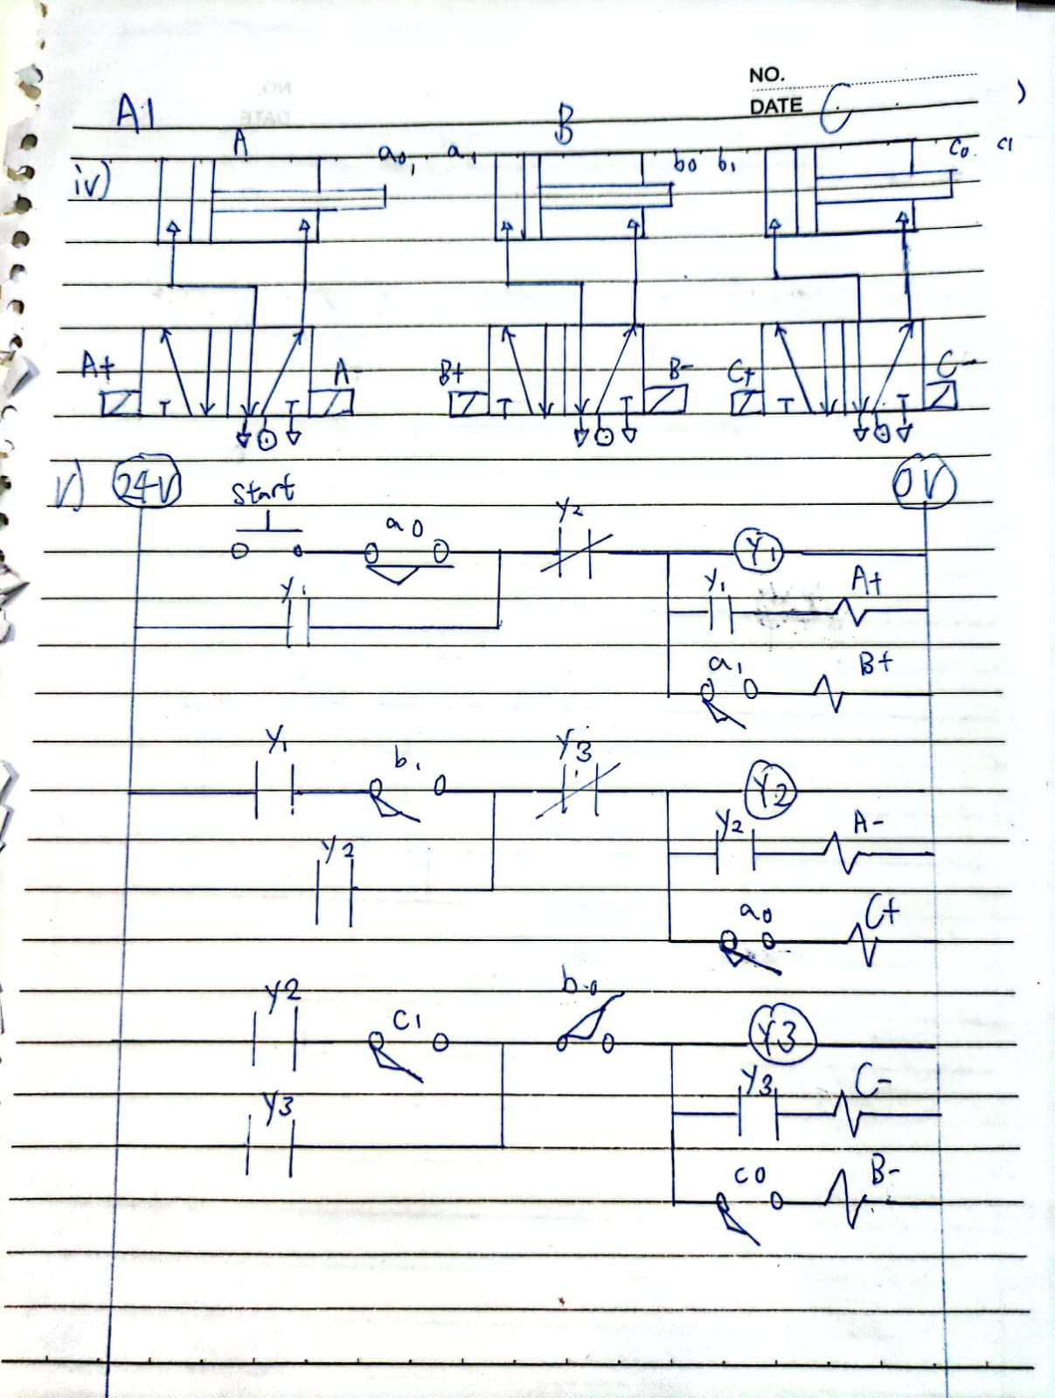

**A2. Same requirement as A1 above, change the solenoid valves to 5/2 single solenoid spring return valves. (20%)**

1. **Pneumatic sub-circuit**
2. **Electrical ladder**

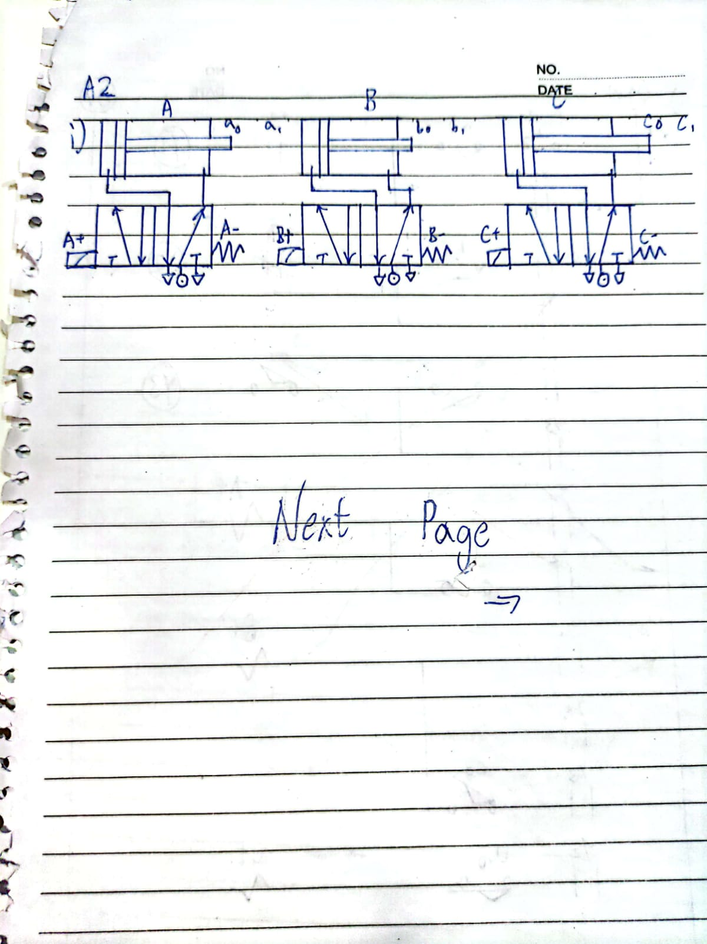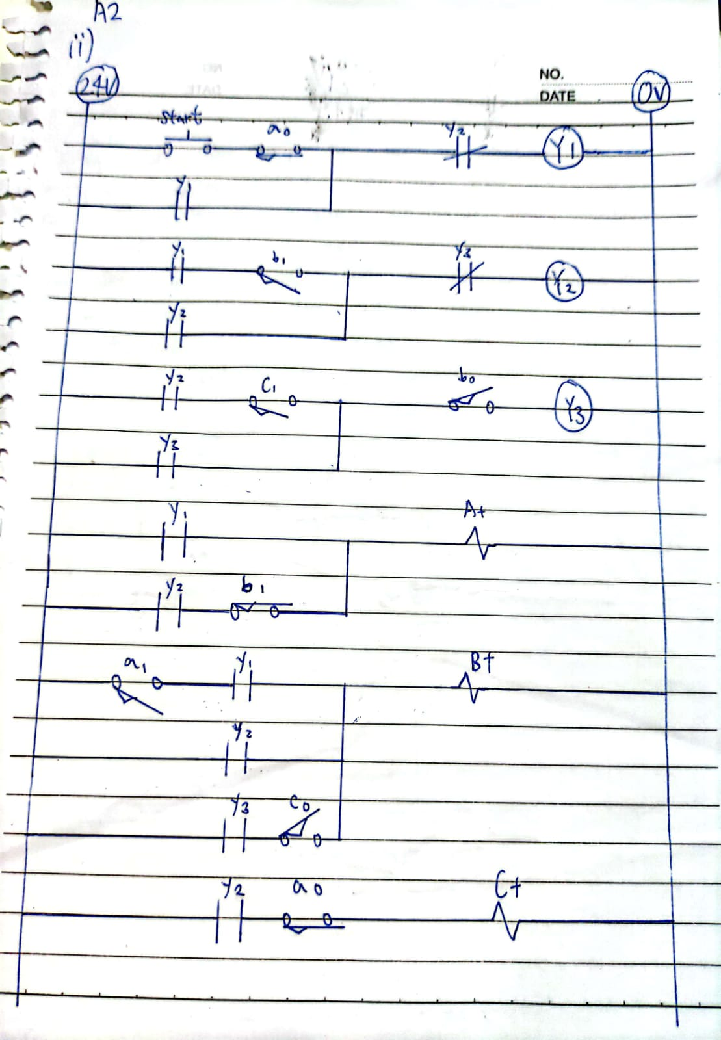

**A3. Add an option of single or continuous cycle operation to A1 and A2. (10%)**

* You may use another ink to identify the modification.

**A3(A1):**

**A3(A2):**

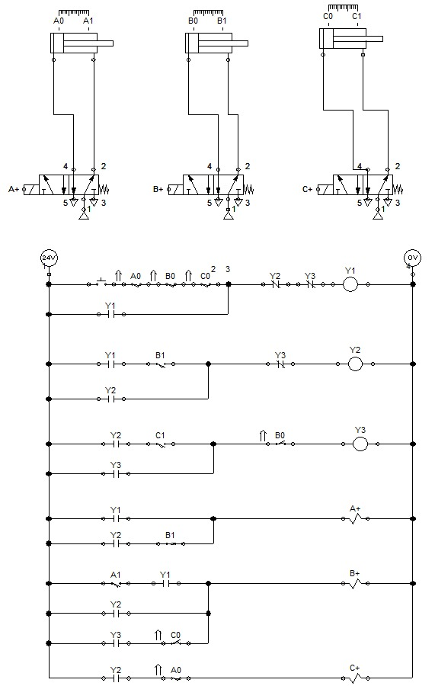

**A4. Add an emergency stop button (E-STOP) to A1 and A2, such that when the button is pressed, all cylinders will immediately return to their initial state. (10%)**

* You may use another ink to identify the modification.

A4(A1):

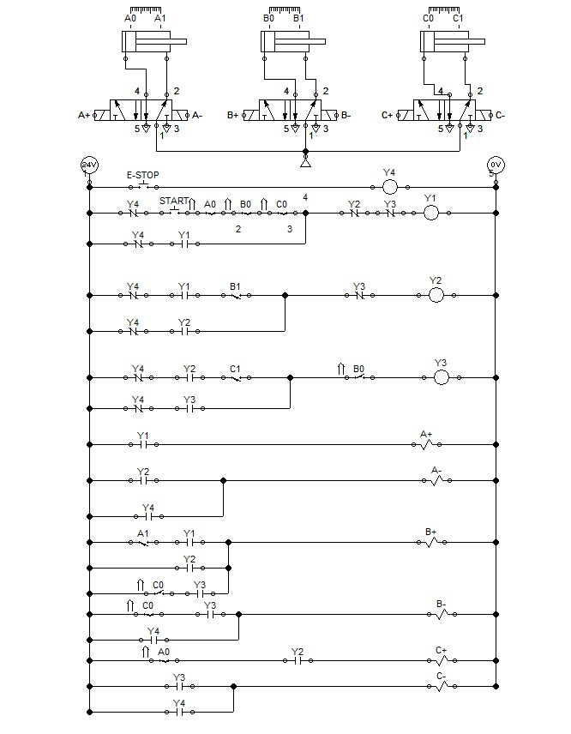

A4(A2):

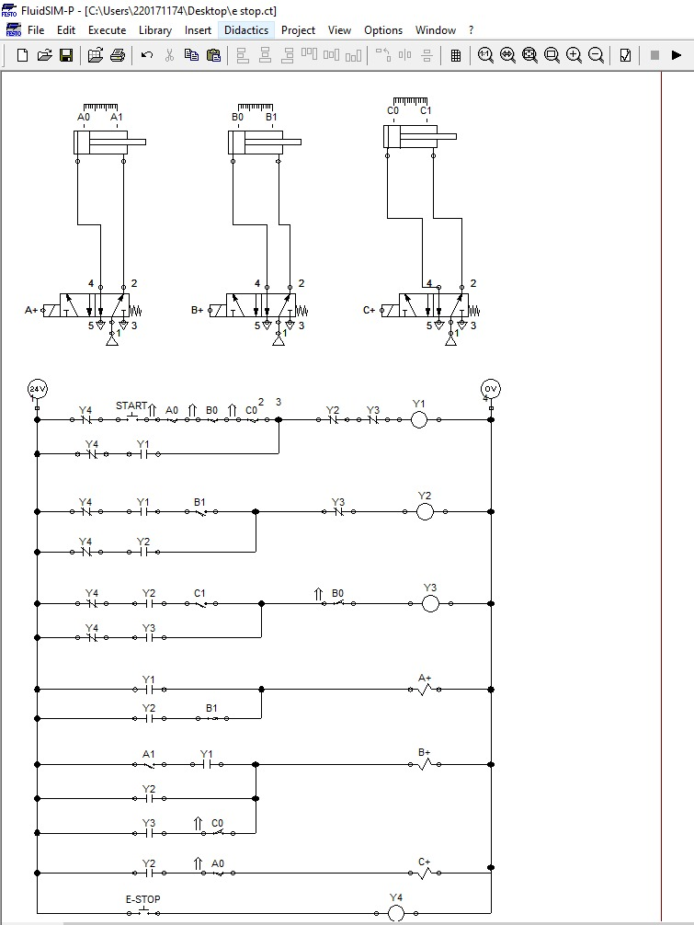

**A5. If only single acting cylinders are available, suggest how the above designs should be modified. (10%)**

**Part B –Discussion (30%)**

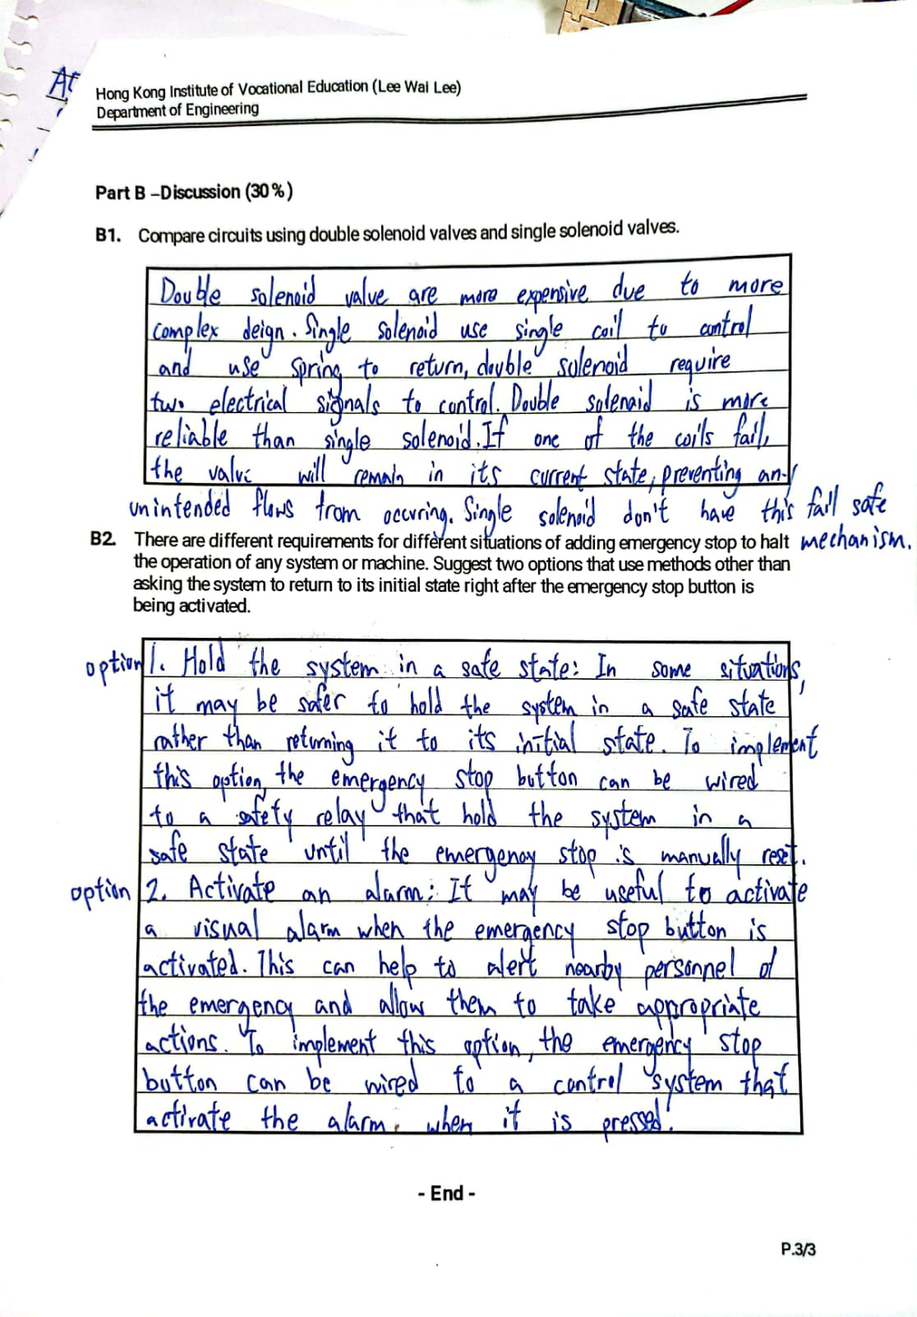**- End -**